Intro: This is a series of seven lessons. Each lesson will usually include time for group discussion and prayer. The main aim is to work through seven of Paul’s prayers in such a way as that we hear God speak to us today. The hope is that we grow in our knowledge of God and his will through our study. Jesus taught his disciples to pray (Luke 11:1-4) and that teaching very much applies to us today – giving us an outline we can use for our prayers. By studying the prayers of Paul, we can grow in our communication with God as we learn from the most influential Christian who ever lived.

By seeking to learn all that we can from what Paul prayed for and how he prayed, it is hoped that we experience a transformation in our walk with God both individually and collectively. It is suggested that you read over each passage before the lesson and try to answer the questions for reflection. You may also find it helpful to use the passages we are studying as the basis for some of your own times of prayer, by yourself or with others, since we can learn so much by ‘praying with Paul’. It will help to take notes during the lessons and also to discuss what you are learning and reflecting on with others.

Titles of the Seven Lessons:

Lesson 1: Foundations of Prayer (2 Thessalonians 1:3-12)

Lesson 2: Praying for Others (1 Thessalonians 2:17-3:13)

Lesson 3: Paul’s Prayer for Colossians (Colossians 1:1-14 esp 1:9-14)

Lesson 4: Overcoming the Obstacles (Philippians 1:1-11 esp 1:9-11)

Lesson 5: Praying to the Sovereign God (Ephesians 1:3-23 esp 15-23)

Lesson 6: Praying for Power (Ephesians 3:14-21)

Lesson 7: Prayer for Ministry (Romans 15:14-33 esp 15:30-33)
The Importance of Context:

It is important to remember that the passages we are studying, are taken from letters that were written to different churches, located in particular settings; each in a unique situation. That is why it is important to understand as much as possible about each church, when studying what Paul writes. We can then have deeper insight into what the letter meant when it was written. This helps us to discern what if means for us today.
To further increase your understanding, you could study the books that the passages are taken from. Commentaries and Bible Handbooks give valuable background information and depth of knowledge. To help put the letters in context, the map below shows the location of the churches that Paul wrote to (identified by dot and circle).
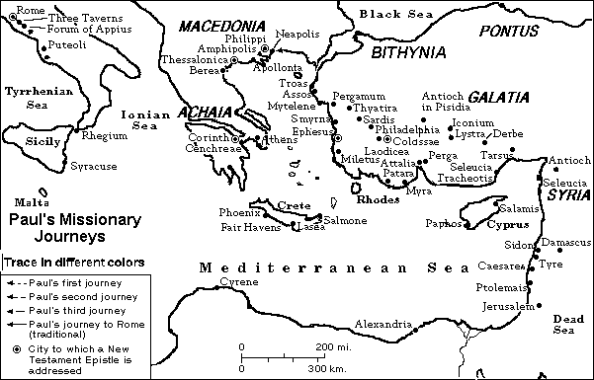

Figure 1. The cities of New Testament times

Questions for Review & Reflection (from ‘A Call to Spiritual Reformation’):

Lesson 1: Foundations of Prayer (2 Thessalonians 1:3-12)

- For what does Paul give thanks? For what do you give thanks?
- What kinds of things in people’s lives should call forth our most profound gratitude to God? Why?
- How does Paul’s anticipation of Jesus’ return shape his values and his prayers?
- What other New Testament teaching can you think of that encourages us to live (and pray!) with eternity’s values in view?
- What good faith-prompted purposes have you been developing and praying about?

Lesson 2: Praying for Others (1 Thessalonians 2:17-3:13)

- In what way does Paul’s prayer in 1 Thessalonians 3:9-13 show his passion for people?
- How about faithfully praying for a Christian (or Christians) for whom you do not now pray. After you have been at it a few months, tell the person you are doing so – and then keep on doing so.
- According to this passage, what is Paul’s source of joy? What is yours? How is our source of joy likely to be related to what we pray for?

Lesson 3: Paul’s Prayer for Colossians (Colossians 1:1-14 esp. 1:9-14)

- List the positive and negative things you have learned about prayer by listening to others pray.
- List practical ways in which you will commit yourself to improve your prayer life during the next six months.
- Granted that one aim in praying is that you might be utterly pleasing to the Lord Jesus, what concrete things in your own life should you be praying about?
- What praying do you do for believers do you do for believers you have never met? How can you improve in this area?
- What connections do joyful thanksgiving and faithful endurance have with prayer?

Lesson 4: Overcoming the Obstacles (Philippians 1:1-11 esp. 1:9-11)

- Do you ever appeal to any excuses to justify your own prayerlessness? Which ones? Are they any good?
- Does God accept us on the basis of whether or not we feel like praying? If not, on what basis does he accept us? How should this affect the priority we assign to prayer?
- What percentage of your praying is for things of eternal value? Do you think your prayers should change? Why or why not?
- How does Paul avoid making the pursuit of what is excellent an idolatrous exercise? How should his example apply to you?

Lesson 5: Praying to the Sovereign God (Ephesians 1:3-23 esp. 15-23)

- If we grant that God is absolutely sovereign, and that we also have responsibility for our choices and actions, how does that influence your prayers?
- What are Paul’s petitions in Ephesians 1? Summarize them in your own words. Do regularly pray for such things? Why or why not? How can you improve in this respect?
- Of what relevance to your life if the stunning conclusion to Paul’s prayer, where he records the best analogy to the power he wants to see operating in every believer’s life?
- What does this passage teach us about how to pray under the sovereignty of God?

Lesson 6: Praying for Power (Ephesians 3:14-21)

- How did you learn to pray? What have been the dominant influences on your prayer life?
- Summarise the two petitions of Paul’s prayer in Ephesians 3:14-21.
- What are the purposes of these two petitions?
- To what extent have you incorporated either or both of these petitions (not necessarily in exactly the same words) into your praying?
- What are the two grounds for Paul’s prayer, as Paul reports them?
- What grounds or reasons lurk behind your prayers? How can you improve on these?
- What steps can you take to make the glory of God the central concern of your life?

Lesson 7: Prayer for Ministry (Romans 15:14-33 esp. 15:30-33)

- Are your prayers for others characterized by earnestness, urgency persistence? If not, why not?
- To what extent does love for the gospel and for gospel outreach drive your prayers? How can you improve in this area?
- Do you feel some of your prayers have not been answered? Have you received answers you did not expect? What light can you shed on your experience?
- Think through particular hurdles Christian leaders face in your church or group, and pray (preferably with others) for these leaders.

Lessons are based on ‘A call to spiritual reformation’ by D.A.Carson (Inter-Varsity Press, 1992)
Commentaries can be found at www.crosswalk.com. An excellent commentary on the whole Bible is Matthew Henry’s Commentary (Cost £25-30). An excellent Bible Handbook is ‘The Lion Handbook to the Bible’ ~£18 (both available from Cornerstone Bookshop, North Finchley, 020 8446 3056)
N.B. These questions are for reflection before the lesson and review after the lesson. You may find that other questions are more relevant to your particular situation and so these are only a guideline.

